Wetaskiwin Welcoming Week & City Open House
Parade of Programs Fall 2026

The Wetaskiwin Parade of Programs is a community fair where local clubs, non-profit organizations, sports groups, and city services gather in one location to showcase their upcoming activities and resources to residents.

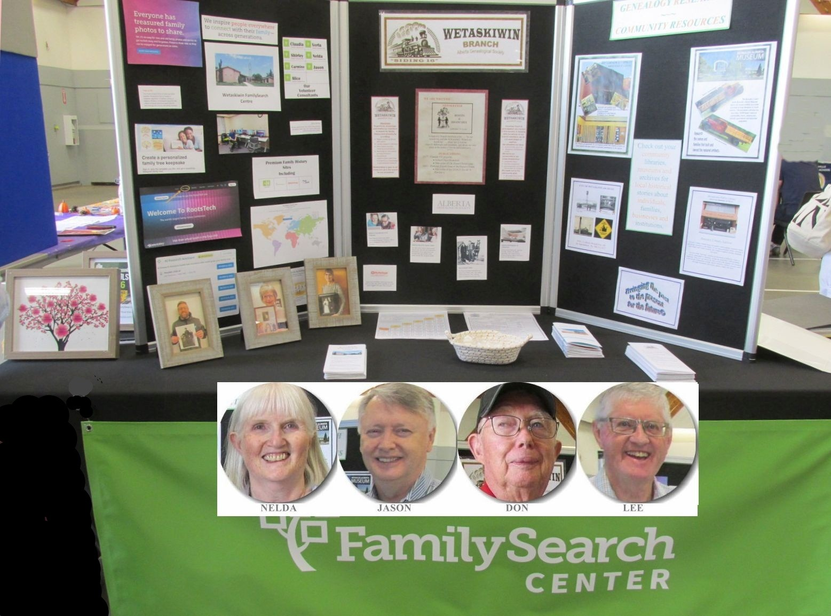
On Wednesday, September 9th, the Wetaskiwin Branch of AGS shared a table with the Wetaskiwin FamilySearch Center to encourage community members to get involved in genealogy. There was a display, brochures and friendly and informed members from each organization to meet the public, answer questions, and promote membership in AGS and family history research at the FamilySearch Center.

